ACADEMIA INTERNACIONAL DE DAVID


TECHNOLOGY
SUMMATIVE ACTIVITY # 1

NAME: __________________________DATE: _______________________ 3^{rd Grade}: A B C
TEACHER: EDGAR PITTY
INSTRUCTIONS: READ THE WORKSHOP CAREFULLY. DO NOT USE PEN. DOUBLE ANSWERS OR CROSS OUTS ARE NOT VALID. RETURN THE ASSIGNMENT AFTER YOU FINISH OR BEFORE THE END OF THE CLASS.
Name and date: 1pt |  | Follow Instructions: 2pt
Order: 1pt |  | Correct use of tools: 1pt
CONTENT: 25 pts |  | TOTAL: 30pts

Part I: Paint the following images and then write the correct name above each image. Check your spelling. Name 1pt each, coloring 1pt each. 20pts total
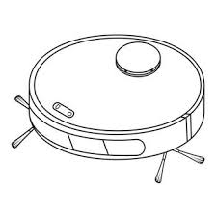
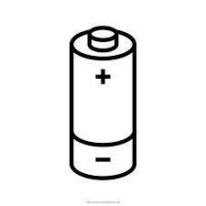
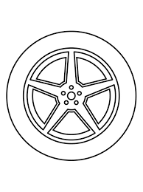
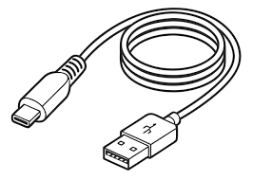

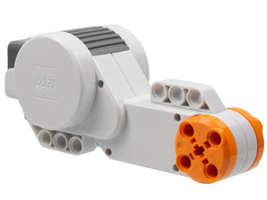
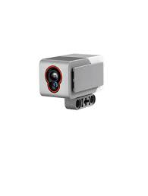
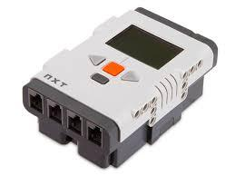
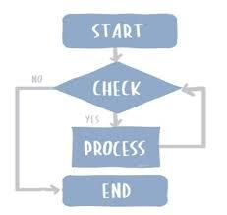


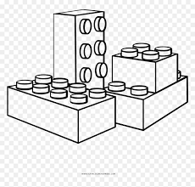

Part II: Write the correct answer for the following questions. Check your spelling. 1pt each 5pts total.
Word Bank
Robot | Task | Controller | Sensor | Motor

- A job or action that a robot performs: ____________________________________________.
- A part that makes the robot move: ____________________________________________.
- A machine that can do tasks automatically: ___________________________________.
- The brain of the robot: ____________________________________________.
- A part that helps a robot detect things: ______________________________________.

